**Pakistan Used Car Prices 2023**

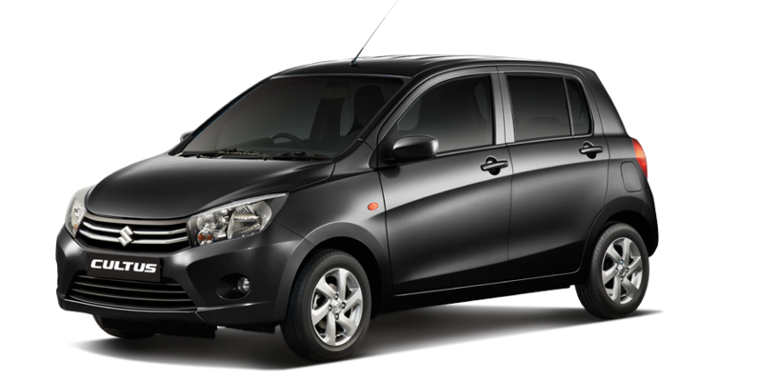

introduction

This data has been scraped from PakWheels, the most renowned second-hand Car Selling company's website. The data contains approximately more than 78,000 cars with 13 different features and price as target.

It consists of 14 columns and 77879 rows.

feature names are:

1. ad_ref: a unique ad reference
2. city: advertisement city (location where vehicle is sold)
3. assembly: imported or not (local)
4. body: body type of vehicle
5. make: manufacturer of vehicle
6. model: model variant of vehicle
7. year: year of production
8. transmission: Auto/Manual
9. engine_CC: engine volume of vehicle
10. fuel type: petrol, diesel of hybrid
11. color: color of vehicle
12. registered: registration number city/province of vehicle
13. mileage: mileage in kms
14. price: price of vehicle in PKR

Analysis Questions::

1. What is the Average Price by Car Make?
2. Do the Price Differences by Fuel Type?
3. What are the Most Common Car Models?
4. What are the most popular car colors in the dataset are?
5. What is the Most Common Body Type?
6. Do the Price Differences by Fuel Type?
7. What is the Top 10 High Average Prices Cities

Dataset link

<https://www.kaggle.com/datasets/talhabarkaatahmad/pakistan-used-car-prices-2023>.